1. Write a pig script find the average age of male and female persons died in the titanic tragedy

Loading the file TitanicData.txt into relation a1:

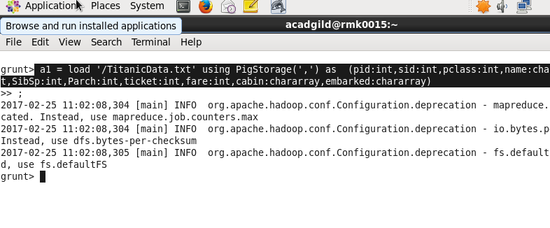

Filtering the persons who died in the titanic tragedy:

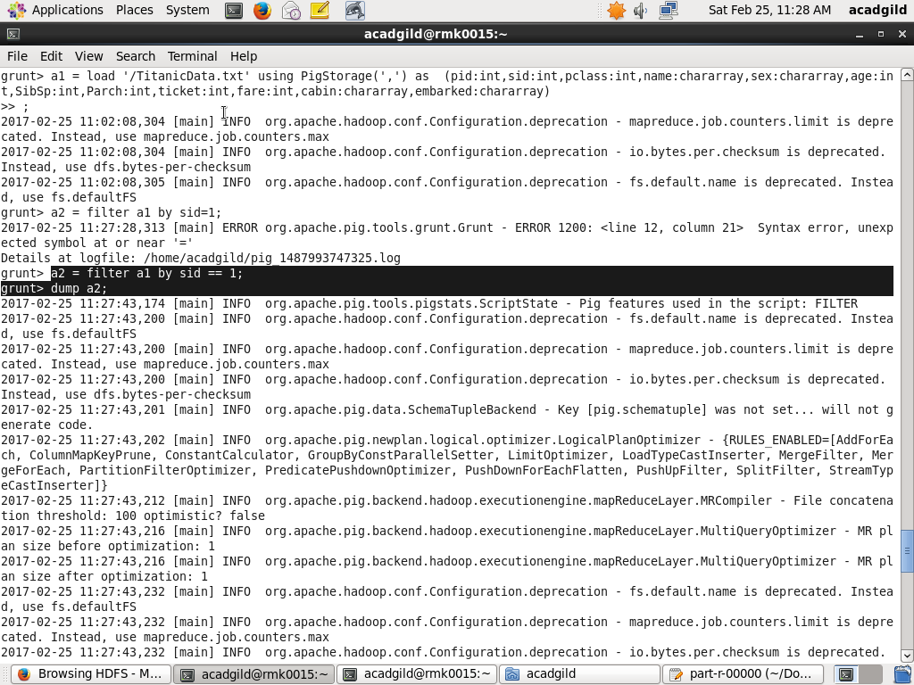

Grouping the persons who died based on gender:

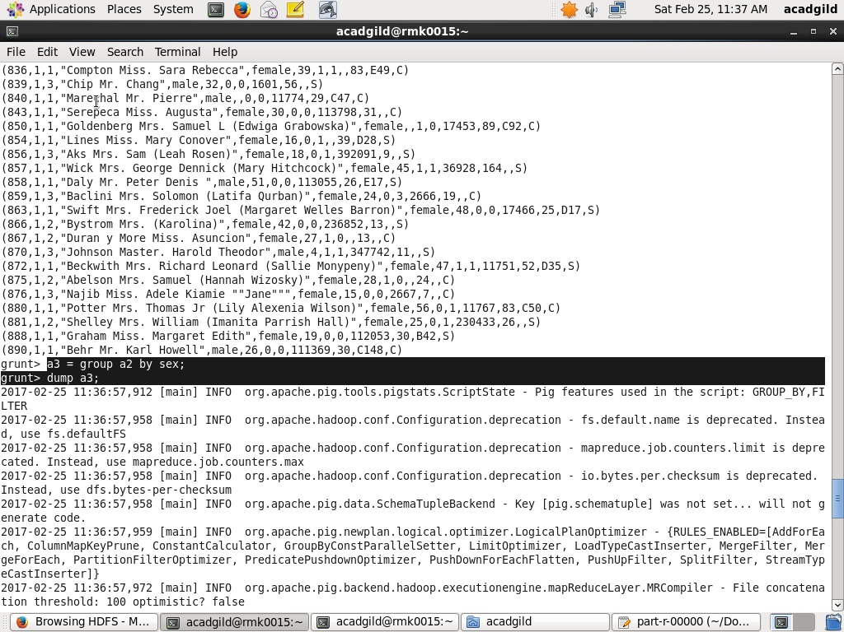

After grouping generating average age based on gender:

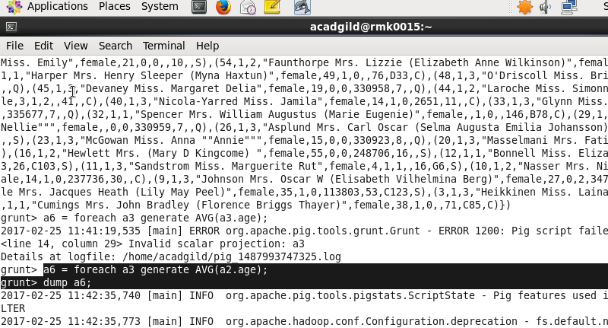

After generating the average it is displayed using the dump command

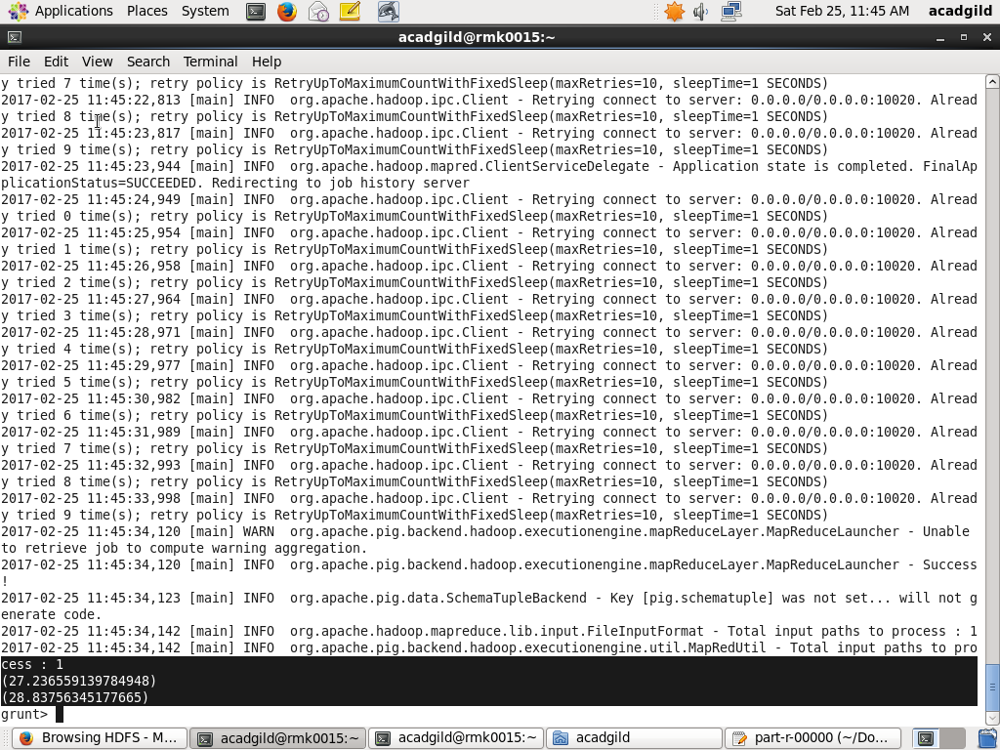

Store command is used to store that relation:

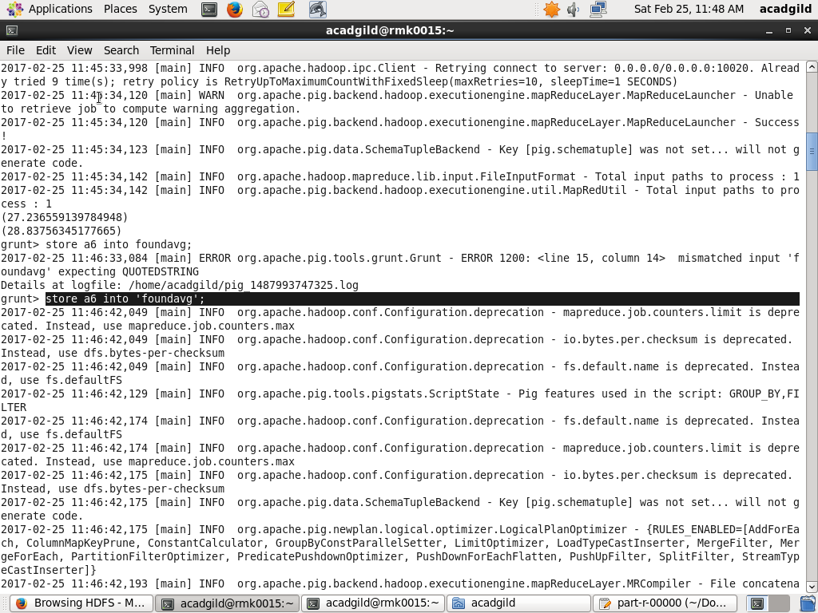

The foundavg file output:

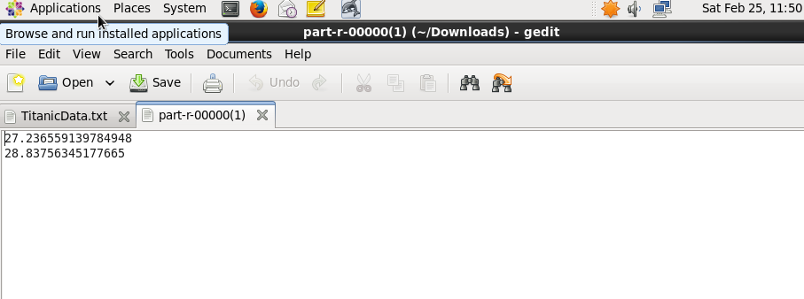

1. Write a pig script to find the number of people died and survived in each class?

Grouping of dead people based on class:

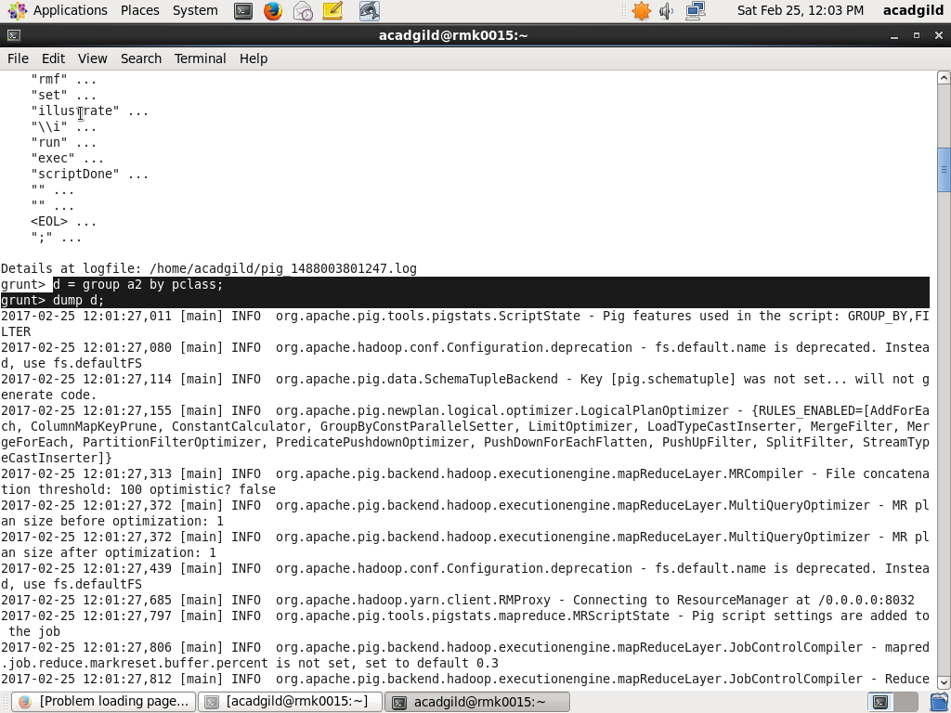

Counting people who have died in the order of class:

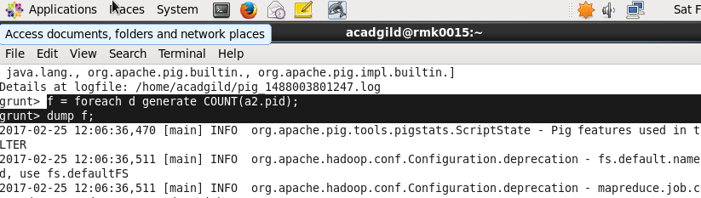

Number of people who died in each class:

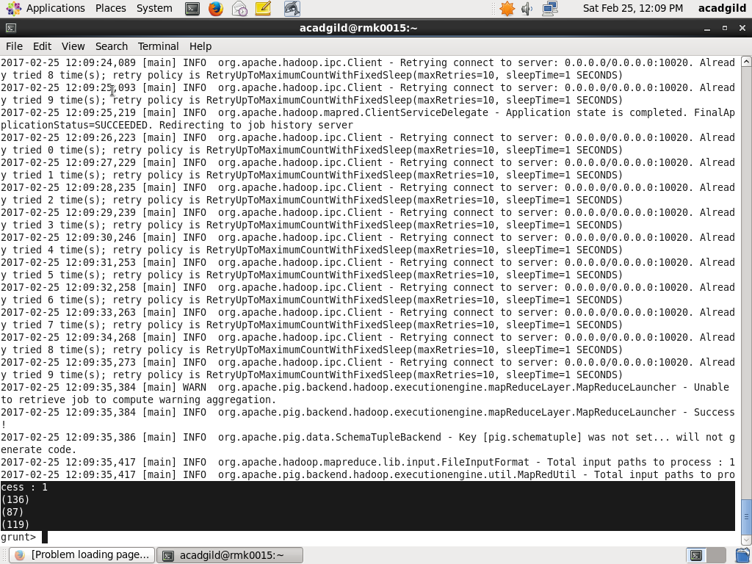

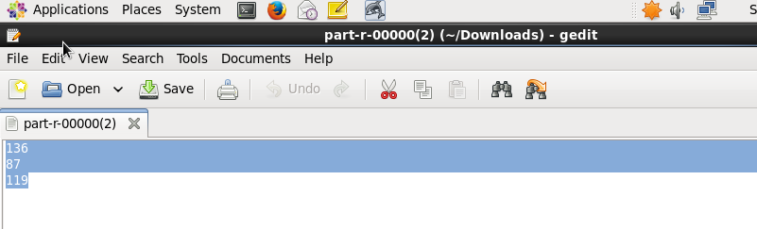

People who are alive are grouped:

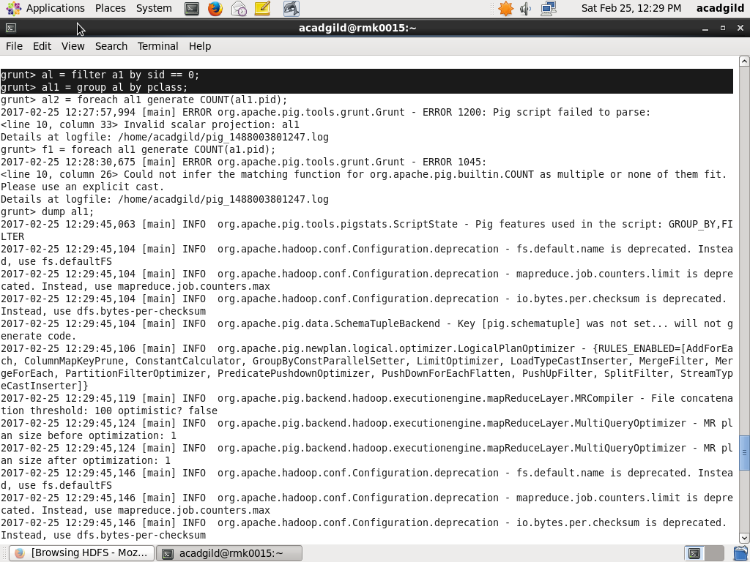

Survived people count:

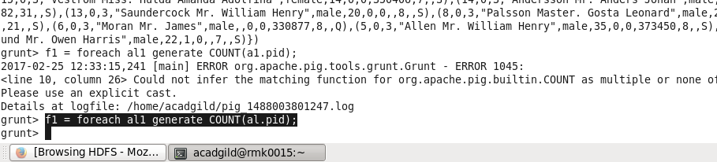

Number of people survived in each class:

